Criminal gangs are inflicting pain and suffering on vulnerable people in Essex towns and rural communities by taking over their homes.

Cuckooing
Crimestoppers in Essex has launched a campaign to try to stop these gangs which use violence and abuse to target the homes of vulnerable people and use them as bases for drug dealing. This is known as ‘cuckooing’.
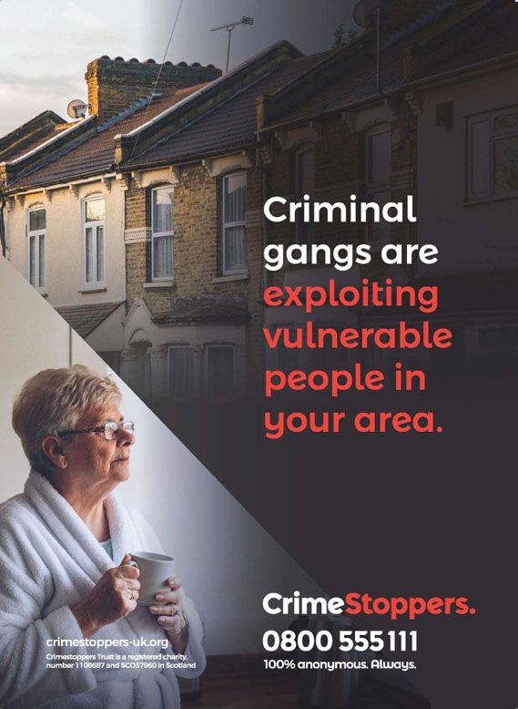
Everyone has the right to feel safe from crime, wherever they live and work.
Crimestoppers wants your help to make communities safer.
If you have any suspicions or information about `cuckooing’, please let us know. You can speak to our Contact Centre on 0800 555 111 or click here to use our non-traceable online form. You will remain 100% anonymous. Always.
We’re an independent charity that gives people the power to speak up to stop crime. 100% anonymously. Always. You can contact us by phone on 0800 555 111 and online,
24/7, 365 days a year.
We’re not interested in your identity. We won’t ask your name. Won’t judge. Just listen to what you know and pass it on for you. When you hang up the phone or click send online, you’re done.

Who are the victims of cuckooing?
Victims of ‘cuckooing’ are often drug users but can include older people, those suffering from mental or physical health problems, female sex workers, single mums and those living in poverty. Victims may suffer from other forms of addiction, such as alcoholism.
Once they gain control, gangs move in with the risk of domestic abuse, sexual exploitation and violence. Children as well as adults are used as drug runners.
It’s common for gangs to have access to several addresses. They move quickly between vulnerable people's homes for just a few hours, a couple of days or sometimes longer. This helps gangs evade detection.
These gangs may use accommodation in rural areas, including serviced apartments, holiday lets, budget hotels and caravan parks.
Some vulnerable adults may be forced to leave their homes, making themselves homeless and leaving the gangs free to sell drugs in their absence.

What are the signs of cuckooing?
Signs that 'cuckooing' may be going on at a property include:
- An increase in people entering and leaving
- An increase in cars or bikes outside
- Possible increase in anti-social behaviour
- Increasing litter outside
- Signs of drugs use
- Lack of healthcare visitors
Speak up to stop crime. Let’s make Essex safer together.
